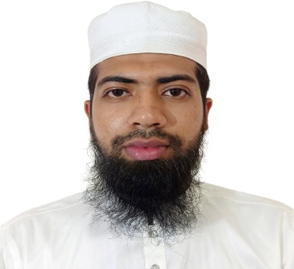

**REFERENCE**

**PROJECT-4**

**PROJECT-3**

**PROJECT-2**

**PROJECT-1**

**TALAL**

**MAHMUD**

**To** build my career as a software professional where I can show my skills and prove myself as an adaptive learner and highly qualified professional and help my skills and specializations. I always look for challenges where I can use my potential at most and always love to work in innovative technologies.

**Calculator**

Technologies: C# .Net

**NotePad**

Technologies: C# .Net

**Country Search**

Technologies: HTML, CSS, JavaScript, React JS

**User Management**

Technologies: HTML, CSS, JavaScript, React JS,

Express JS, Node JS, MongoDB

**Dr. Rafiqul Islam**

**Professor**

Department of Computer Science and Engineering

Dhaka University of Engineering and Techhnology, Gazipur

**PROJECTS**

**SUMMARY**

**EDUCATIONS**

**SKILLS**

**CONTACT ME**

 +88 0163 5894153

 [mahmudtalal2@gmail.com](mailto:mahmudtalal2@gmail.com)

Torgaon, Kapasia, Gazipur

 [www.linkdin.com/mahmudtalal2](http://www.linkdin.com/mahmudtalal2)

**BSC in Computer Science and Engineering**

Dhaka University of Engineering and Technology

CGPA – 2.87 out of 4.00 | 2022

**Diploma in Electronics Technology**

Dhaka Polytechnic Institute

CGPA – 3.64 out of 4.00 | 2016

**SSC**

Kohinur Boys High School

Science | Dhaka Board

GPA – 4.81 out of 5.00 | 2011

* C++
* Python
* C# .Net
* PHP
* MySql
* JavaScript
* HTML
* CSS